**Problem statement 3: Emp id :**

**The Annual Closet Inventory Management Name :**

CREATE DATABASE shirts_db;

USE Shirts_db;

CREATE TABLE Shirts (

shirt_id INT PRIMARY KEY AUTO_INCREMENT,

article VARCHAR(20),

color VARCHAR(20),

shirt_size VARCHAR(10),

last_worn INT);

INSERT INTO Shirts(article, color, shirt_size, last_worn) VALUES

('t-shirt', 'white', 'S', 10),

('t-shirt', 'green', 'S', 200),

('polo shirt', 'black', 'M', 10),

('tank top', 'blue', 'S', 50),

('t-shirt', 'pink', 'S', 0),

('polo shirt', 'red', 'M', 5),

('tank top', 'white', 'S',200),

('tank top', 'blue', 'M', 15);

**# 1. Add a New Shirt-Purple polo shirt, size M last worn 50 days ago**

INSERT INTO Shirts(article, color, shirt_size, last_worn) VALUES

('polo shirt','purple','M',50);

#2. **SELECT all shirts -But Only Print Out Article and Color.**

SELECT article,color FROM Shirts;

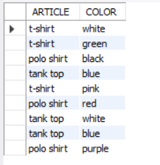

#3. **SELECT all medium shirts -Print Out Everything But shirt_id.**

SELECT article,color,shirt_size,last_worn FROM Shirts

WHERE shirt_size='M';

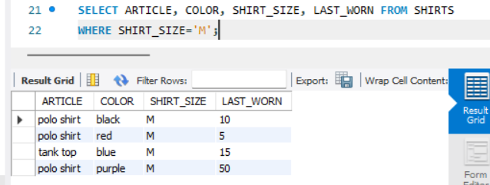

#4. **Update all polo shirts -Change their size to L.**

UPDATE Shirts

SET shirt_size='L'

WHERE article='polo shirt';

#5. **Update the shirt last worn 15 days ago -Change last_worn to 0.**

UPDATE Shirts

SET last_worn=0

WHERE last_worn=15;

#6. **Update all white shirts -Change size to 'XS' and color to 'off white'.**

UPDATE Shirts

SET color='off white',shirt_size='XS'

WHERE color='white';

#7. **Delete all old shirts -Last worn 200 days ago.**

DELETE FROM Shirts WHERE last_worn=200;

#8. **Delete all tank tops.**

DELETE FROM Shirts WHERE article='tank top';

